Tags in ansible

vi ansible-tag.yml

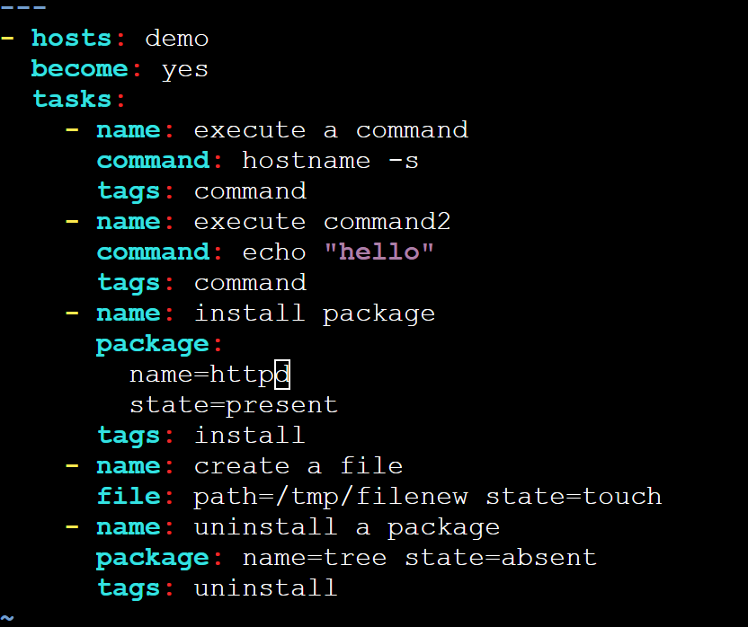

ansible-playbook ansible-tag.yml --tags install,command

ansible-playbook ansible-tag.yml --skip-tags uninstall

ansible-playbook ansible-tag.yml --tags untagged

ansible-playbook ansible-tag.yml --tags tagged

## Always tag:

Always run the tasks unless you explicitly use –skip-tags to stop running the tasks

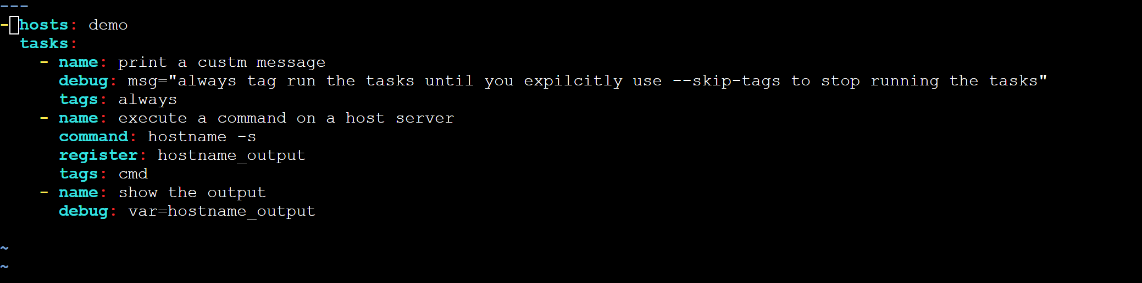

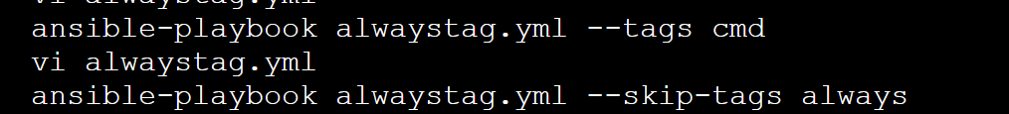

### NEVER TAG : A task will never run unless you expilicitly use the –tags flag to run the tasks



